IP25: Text for social media posts
Card 1:
Last year, more than 60,000 people took part in the #AdultInpatientSurvey to make their voices heard. Now, it’s your turn.
Your valuable feedback will help us improve the quality of our care and people’s experience.
If you’re selected to take part, you’ll receive the #AdultInpatientSurvey in the post soon.
Find out more about the survey: [INSERT TRUST PRESS RELEASE LINK FOR ADULT INPATIENT SURVEY IF AVAILABLE]
Further information on Section 251: Confidential patient information - Health Research Authority

Social media card: Take action
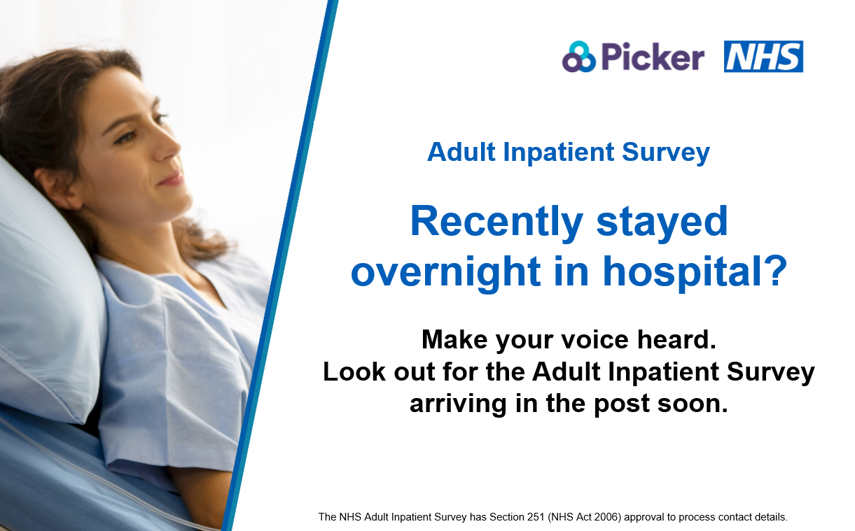

Card 2:
We’d love to hear about your experience of your overnight stay in hospital. The best way for us to improve our care is by listening to the people who have recently used our services.
Last year, more than 60,000 people shared their experiences. This year, we want to hear about yours.
If you’re selected to take part, you’ll receive an invitation in the post and a text message reminder.
Find out more about the survey: [INSERT TRUST PRESS RELEASE LINK FOR ADULT INPATIENT SURVEY IF AVAILABLE]
Further information on Section 251: Confidential patient information - Health Research Authority

#AdultInpatientSurvey
Social media card: Reminder One
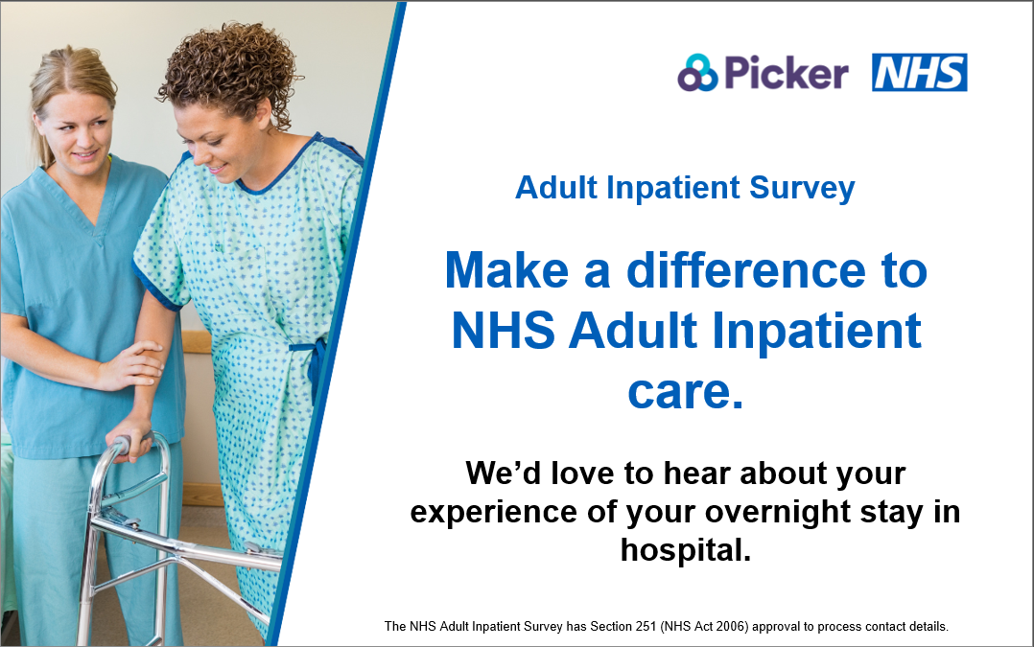

Card 3:
Since 2002, the #AdultInpatientSurvey has helped thousands of people make their voices count. Every voice helps shape the future. Let yours be heard today.
If you’re selected to take part, you’ll receive the #AdultInpatientSurvey in the post soon.
Find out more about the survey: [INSERT TRUST PRESS RELEASE LINK FOR ADULT INPATIENT SURVEY IF AVAILABLE]
Further information on Section 251: Confidential patient information - Health Research Authority

Social media card: Reminder Two
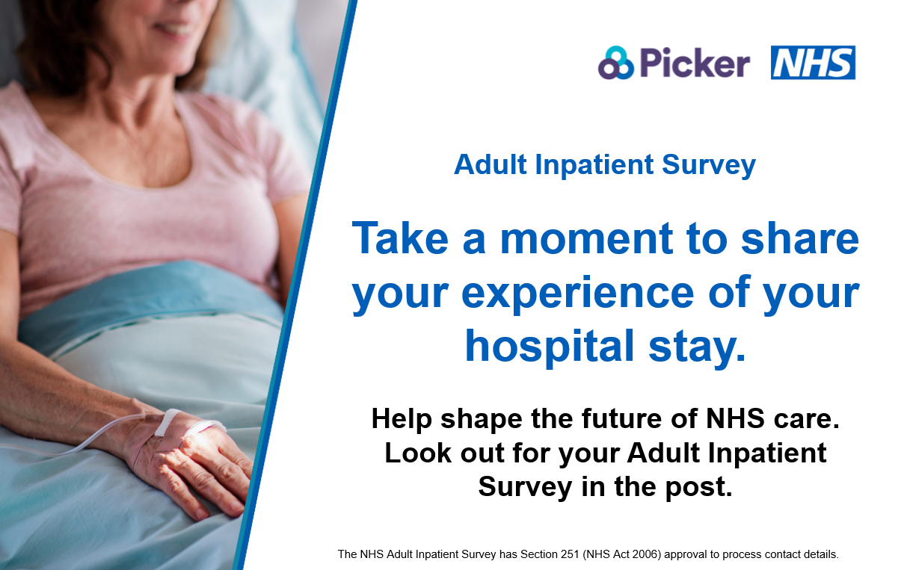

Card 4:
Every voice matters. Share your experiences today and help us improve our NHS inpatient care for everyone.
If you’re selected to take part, you’ll receive an invitation in the post and a text message reminder with a survey link to share your experience.
Find out more about the survey: [INSERT TRUST PRESS RELEASE LINK FOR ADULT INPATIENT SURVEY IF AVAILABLE]
Further information on Section 251: Confidential patient information - Health Research Authority

#AdultInpatientSurvey
Social media card: Reminder Three
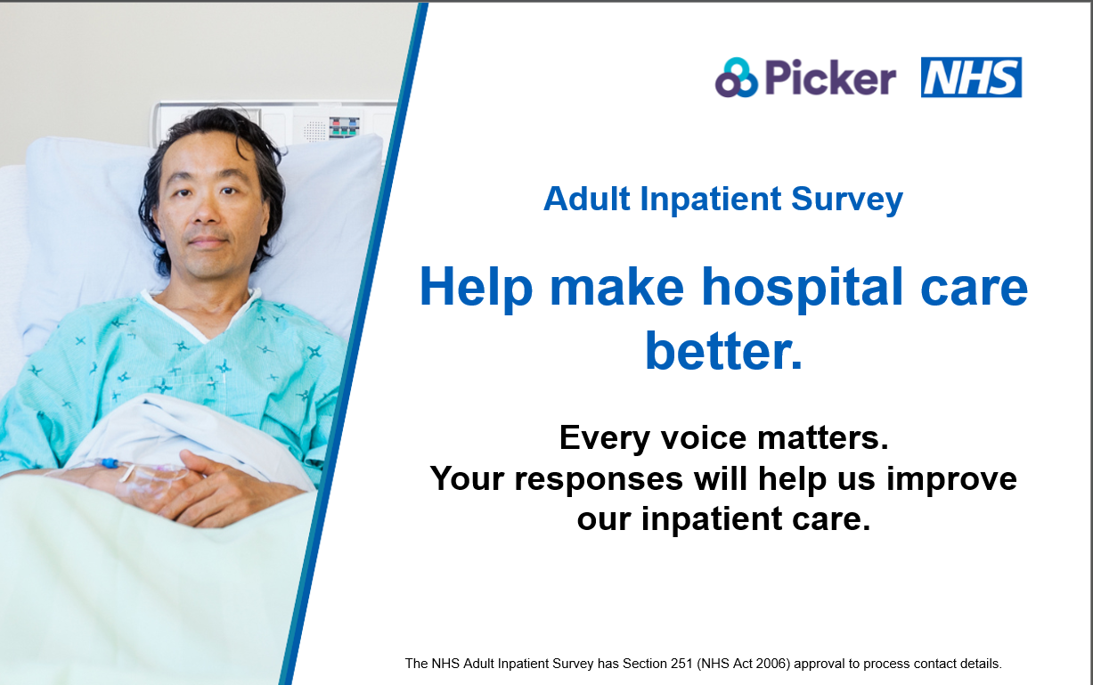

The NHS Adult Inpatient Survey has Section 251 (NHS Act 2006) approval to process contact details.

